Master Project XXX

MASTERTESTPLAN

ID: Mastertestplan

Version 1.x
Rev. x

Authors:

Date\Signature: ________________________________

Quality Assurer:

Date\Signature: ________________________________

Project manager:

Date\Signature: ________________________________

Head of project:

Date\Signature: ________________________________

Document History
Version No. | Date | Authors

Revision Sheet

Revision No. | Date | Reviewer | Revision Description
0 | xx\06\2008 |  | Creation of this master test plan.
1 | xx\06\2008 |  | Include system overview. Review of system strategy.

Introduction

Background
The purpose of this document is to introduce the test plan of the Publication Document Workflow Management System (PD WMS). The document summarizes the test objects, test strategy, the time plan and the resources and responsibilities required to perform the test plan.

The plan described in this document based on the Requirements Document of the Master Project OSP07 [1.2 Nr. 1].

Referenced documents
Nr | Name | Document position
1 | Requirements Document of the Master Project OPS07 | ~\Requirements_documentation\Requirements_Specification.doc
2 | Unittestplan 1.0.0 | ~\Products\Testing\Documents\unittestplan 1.0.0.doc
3 | Integrationtestplan 2.0.0 | ~\Products\Testing\Documents\integrationtestplan 2.0.0.doc
4 | Systemtestplan 3.0.0 | ~\Products\Testing\Documents\systemtestplan 3.0.0.doc
9 | Testpriority_x.x | ~\Products\Testing\Documents\systemtest\
10 | Mastertimeplan | ~\Products\Testing\Documents\Mastertimeplan.mpp

Test objects

System overview
The Publication Document Workflow Management System (PD WMS) of the Fraunhofer IESE consists of five sub-processes: Initial approval, Writing Document, Quality approval, Pre-publish, and Publication and Dissemination. A briefly description of each one of these sub-processes is introduced as follows:
- Initial approval: This would be the start point of the workflow, in which usually a researcher proposes a topic for publication and it has to be approved by his respective Division Head.
- Writing: This sub-process represent the step of the workflow in which the publication is being written by one or more authors. This step would be coordinated by a responsible author.
- Quality Approval: This is the step of the workflow in which; the finished publication document is reviewed by: i) experimentation and\or scientific experts, and ii) the division head, in order to check the quality of the publication’s content.
- Pre – publish: Within this sub-process the final approval for publishing the publication is given by the division head, after the document has been approved for quality.
- Publication and Dissemination: This sub-process represents the final stage of the publication. Within this step, the document is being for-matted and submitted to the library system, to be later classified and archived into the library catalogue.

The following table provide a summary of the functional requirements, in term of use cases, which the test plan should cover. Details about each one of the sub-processes explained above can be found in the Requirements Document of the Master project OSP07 [1.2 Nr. 1].

Sub Process | Id | Use case
Initial approval | 1.1 | Plan Publication Proposal
Initial approval | 1.2 | Propose Publication Proposal
Initial approval | 1.3 | Review Publication Proposal
Initial approval | 1.4 | Assign Experimentation Expert
Writing process | 2.4 | Submit document and classification
Quality Approval | 3.1 | Review of the Document by Expert
Quality Approval | 3.2 | Review of the Document by Division Head
Pre – publish | 4.1 | Attach External Approval
Pre – publish | 4.2 | Review External Approval
Publication and Dissemination | 5.1 | Receive Document for publication & printing
Publication and Dissemination | 5.2 | Store document into the library
Monitor Publication Projects And Statistics | 6.1 | Consult currently involved Publication Projects of Researchers
Monitor Publication Projects And Statistics | 6.2 | View Statistics Information per User
Monitor Publication Projects And Statistics | 6.3 | View Statistics Information per Department
Monitor Publication Projects And Statistics | 6.4 | View Statistics Information per Division
Monitor Publication Projects And Statistics | 6.5 | Consult current Publication Projects

System environment
The PD WMS should aid the employees of the Fraunhofer IESE with their daily work related to the publication process. In order to make the system more usable, the system should be integrated with the tools that are most commonly used by the researchers at Fraunhofer IESE: Microsoft Office. Therefore, the PD WMS should work under the Operating System Microsoft Windows and will be integrated with Microsoft Outlook, as front end.

Test strategy

The project plan considers one week for the component implementation and testing and one week for the integration of the component and testing. Therefore, the test strategy includes Unit, Integration and System test. The testing types will be executed using a bottom up approach. To detail information about the test strategy, pass\fail criteria, interrupt\continue criteria, test environment and resources, please referred to the specific plan: Unittestplan [1.2 Nr. 2], Integrationtestplan[1.2 Nr. 3] and Systemtestplan [1.2 Nr. 4].

Test cases will be designed for each testing type. The design of unit test will base on the components, the design of integration test on the integration plan and the system test on the use case specification.

If the system test is completed according to the plan, during the last week of the project an usability test will be performed in order to obtain a preliminary evaluation of the system usability and a list of required improvement. During the usability test, a sample of users should receive a specific list of tasks to be performed using the final system. Each user will speak aloud to describe how he uses the system. The user actions will be recorded and the collected data will be analyzed to detect relevant issues and improvements.

For the testing of our project it is estimate that for the final number of instructions of the PD WMS nearly 5% bugs can be found with testing after the review. Further on it is assumed that
- by unit test 65 % of coding bugs and no design defects,
- by integration test 30 % of coding bugs and 60 % design defects,
- by system test 3 % of coding bugs and 35 % design defects
will be found. So the testing gets ineffective as soon as this appraised value of each phase will be exceeded.

To trace the test case to the requirement, each test case will have an unique identifier with the following format:

<testing_type>. <sub_process_step>.<test_case>

Where:
- Testing type:
  - Unit test
  - Integration test
  - System test
- Process step
  - Initial approval
  - Writing process
  - Quality Approval
  - Pre – publish
  - Publication and Dissemination
- Test case: correlative number, starting at 1 for each process step.

To priority of each test case, test scenario and test sequence, will be determine as follows:
- Each system function should be prioritized using the KANO method.

- The weight of a test case should be equal to the sum of the priority of the related system functions.

- The weight of a test scenario should be equal to the sum of the weight of the related test cases

- The weight of a test sequence should be equal to the sum of the weight of the related test scenarios

Time plan
The time plan for the testing and the assigned persons can be find in mastertimeplan [1.2 Nr.7]

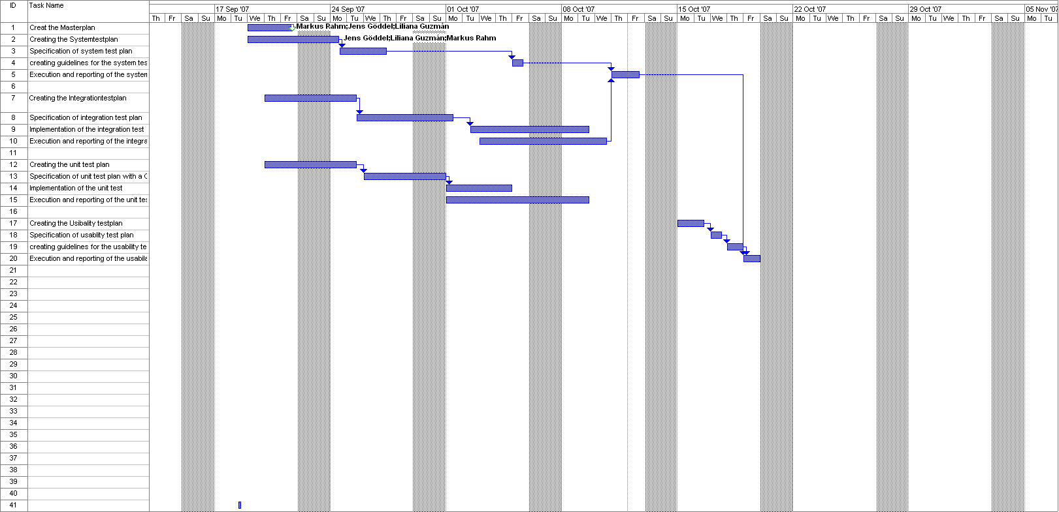

Responsibilities
Test phase | Persons
Unit test
Integration test

See page 247 in Software-Qualitätsmanagement in der Praxis 2. 2001
See page 247 in Software-Qualitätsmanagement in der Praxis 2. 2001

